DANDIYA DAY CELEBRATION REPORT
Date: 1st October 2025
Time: 8:00 AM – 12:00 PM
Venue: IVM’s Sports Ground
Organized by: Krishnarao Bhegade Institute of Pharmaceutical Education & Research (KBIPER), Talegaon Dabhade
The Dandiya Day Celebration was organized with great enthusiasm and festive spirit on 1st October 2025 at the IVM’s Sports Ground for the students of D. Pharm, B. Pharm, and M. Pharm. The event was successfully coordinated under the guidance of Ms. Ashvini Joshi and Mr. Shubham Waghmare (Extracurricular In-charges), with valuable support from Dr. Y. B. Zambare (IQAC Head), Dr. G. S. Shinde (HOD), and Dr. S. R. Arote (Principal, KBIPER).
The celebration began with the traditional Bhondla Pooja, symbolizing devotion, togetherness, and the essence of Navratri. Following the pooja, students enthusiastically participated in Garba and Dandiya Raas, dressed in colorful traditional attire. The sports ground was beautifully decorated with festive drapes and lights, creating a vibrant and joyful atmosphere.
The program was graced by the esteemed presence of Shri Ramdas Appa Kakade Sir (President, Indrayani Vidya Mandir Sanstha), Shri Chandrakant Shete Sir (Secretary, Indrayani Vidya Mandir Sanstha), and Hon’ble Smt. Nirupa Kanitkar Madam, whose presence elevated the occasion. The dignitaries addressed the gathering with motivational words, inspiring students with their guidance and appreciation. Smt. Nirupa Kanitkar Madam also joined the dance, adding charm and encouragement to the celebration.
Faculty members and students actively participated, making the event lively and memorable. The celebration fostered cultural harmony, team spirit, and joy among all attendees.
The event concluded with a vote of thanks delivered by the organizing committee, expressing heartfelt gratitude to the management, respected dignitaries, faculty members, and student volunteers for their immense support and contribution to the success of the celebration.

Highlights:

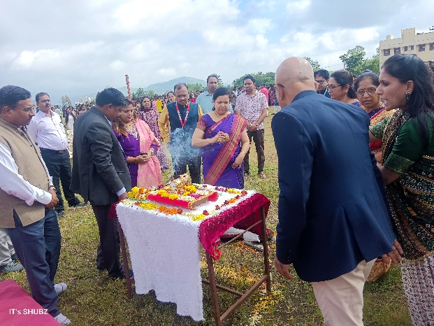

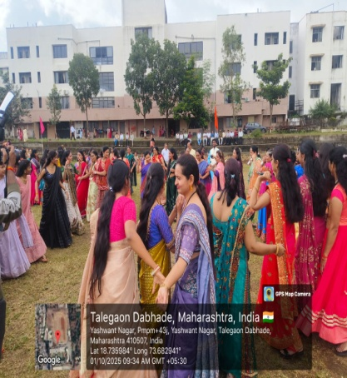
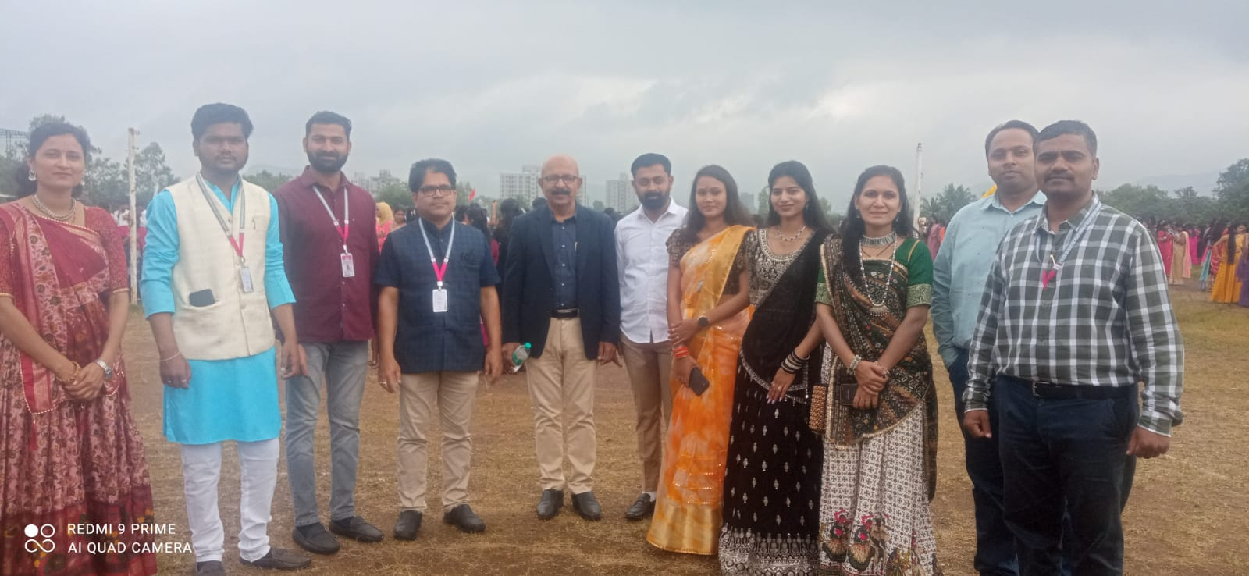
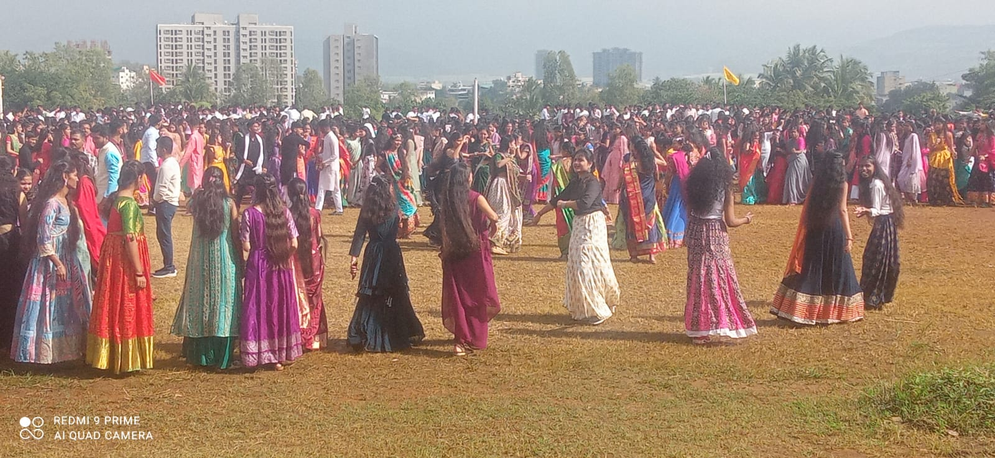

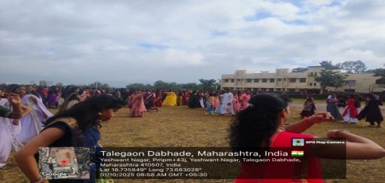

Extracurricular In charges IQAC Head HOD Principal
Prof.A.V.Joshi Dr.Y.B.Zambare Dr.G.S.Shinde Dr.S.R. Arote
Prof .S.M.Waghmare
Talegaon Chakan Road, Talegaon Dabhade, Tal. Maval, Dist. Pune-410507, Maharashtra
Email: principal.iiper@gmail.com Web: https://www.indrayanipharmacy.com

